Numbers Can be Positive or Negative (Mathisfun.com)
Negative Numbers (−) | Positive Numbers (+)

No Sign Means Positive
If a number has no sign it usually means that it is a positive number.
Example: 5 is really +5
Numbers above (greater than) zero are positive. Numbers below (less than) zero are negative.

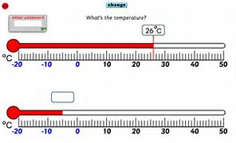
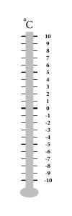
Temp Scale for Integer

The Rules: Adding and subtracting
It can all be put into two rules:
 | Rule |  |  |  | Example
+(+) | Two like signs become a positive sign |  |  |  | 3+(+2) = 3 + 2 = 5
−(−) |  |  |  |  | 6−(−3) = 6 + 3 = 9
+(−) | Two unlike signs become a negative sign |  |  |  | 7+(−2) = 7 − 2 = 5
−(+) |  |  |  |  | 8−(+2) = 8 − 2 = 6
They are "like signs" when they are like each other (in other words: the same).

The Rules: Multiplying and Dividing
 |  |  | Example
× | two positives make a positive: |  | 3 × 2 = 6
× | two negatives make a positive: |  | (−3) × (−2) = 6
× | a negative and a positive  make a negative: |  | (−3) × 2 = −6
× | a positive and a negative  make a negative: |  | 3 × (−2) = −6

What is -9 + (+11) ?
+(+) becomes a positive sign.
So -9 + (+11) = -9 + 11 = 2
Start at -9 and move 11 places to the right:
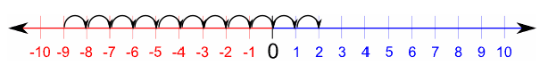

What is -16 + (-3)?

+(-) becomes a negative sign.
So -16 + (-3) = -16 − 3 = -19
Start at -16 and move 3 places to the left:
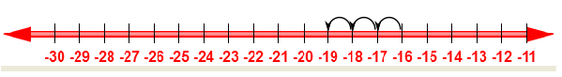

What is 20 + (-7)?
+(-) becomes a negative sign.
So 20 + (-7) = 20 − 7 = 13
Start at 20 and move 7 places to the left:
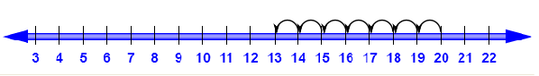

What is -17 + (+13) ?
+(+) becomes a positive sign.
So -17 + (+13) = -17 + 13 = -4
Start at -17 and move 4 places to the right:
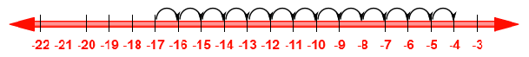
What is the value of (-3) × (-5) ?
Remember that multiplying two negative numbers makes a positive number.
So (-3) × (-5) = +15
We can leave the + sign in the answer, but it's not necessary:
So we can also write (-3) × (-5) = 15
What is the value of (-4) × (+7) ?
Remember that multiplying a negative number by a positive number makes a negative number.
So, (-4) × (+7) = -28

What is the value of (+6) × (-9) ?
Remember that multiplying a positive number by a negative number makes a negative number.
So (+6) × (-9) = -54

What is the square of -7 ?
Remember that multiplying two negative numbers makes a positive number.
So (-7)² = (-7) × (-7) = +49
We can leave the + sign in the answer, but it's not necessary:
So we can also write (-7)² = 49

What is the value of (-2) × (+5) × (-3) ?
Do this in two steps, working from left to right:
1. Work out (-2) × (+5)
Remember that multiplying a negative number by a positive number makes a negative number.
So (-2) × (+5) = -10
2. Work out (-10) × (-3)
Remember that multiplying two negative numbers makes a positive number
So (-10) × (-3) = +30
We can leave the + sign in the answer, but it's not necessary:
So the answer is 30

