Decimals

So, our Decimal System lets us write numbers as large or as small as we want, using the decimal point. Digits can be placed to the left or right of a decimal point, to show values greater than one or less than one.
The decimal point is the most important part of a Decimal Number. Without it we are lost, and don't know what each position means.
17.591
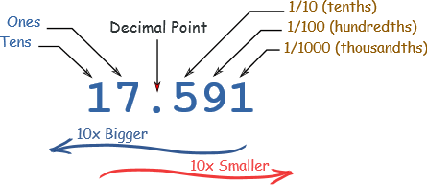

Decimals as fractions and fractions as decimals
2.3 = 2 $\frac{3}{10}$ 5$\frac{6}{10}$ = 5.6

What is the hundredths digit in the number 356.812?
The hundredths digit is the second digit to the right of the decimal point, which is the 1:
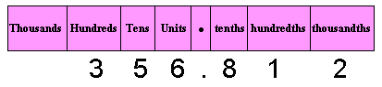
For the decimal number 89.56 what is the digit in the tenths place?
The tenths place comes immediately after the decimal point.
So in this case the digit in the tenths place is 5:
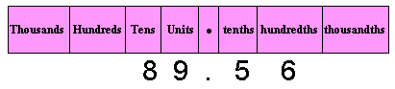

For the number 2367.981, where do you find the largest digit?
The highest place value in the number is the Thousands, but that's not what the question is asking.
The largest digit in the number is 9, which is in the tenths place:
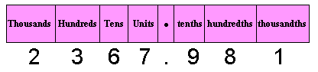

How to convert fractions into decimals
Just divide the top of the fraction by the bottom, and read off the answer! Divide the numerator into

Example: What is 5.8 as a decimal ... ?
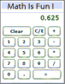
... get your calculator and type in "5 / 8 ="
The answer should be 0.625
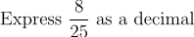
Divide 8 by 25: 8÷25=0.32
--------------------------------------------------------------

Now let’s take this one step further----
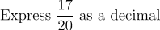

So we divide 17 by 20 = 17 ÷ 20 = .85
Now, we can rewrite .85 as $\frac{85}{100}$
If we simplify $\frac{85}{100}$ by dividing the numerator and denominator by the largest common factor 5, we will get $\frac{17}{20}$ and that is what we started with.

Express ${22}/{25 }$as a decimal and then bring it back to a fraction.

22 ÷ 25 = .88 ${ 88}/{100}$ ${88}/{100}$ ÷ $4/4$ = ${22}/{25}$
Multiply the Decimal Number by 100, and put the "%" sign so people know it is per 100.

Convert decimals to percents
Multiply the Decimal Number by 100, and put the "%" sign so people know it is per 100.
.85 x 100 = 85% (We moved the decimal point two spaces –cuz we have two zeros in 100—and added a percent sign.
Convert ¼ to a percent--
$\frac{1}{4}$ is also 1 ÷ 4 = .25 ,which then can be multiplied by 100
.25 x 100 = 25%
Convert 1/3 to a percent –
1/3 is also 1 ÷ 3 = .33333 that we round to .33, which then can be multiplied by 100
.33 x 100 = 33%

